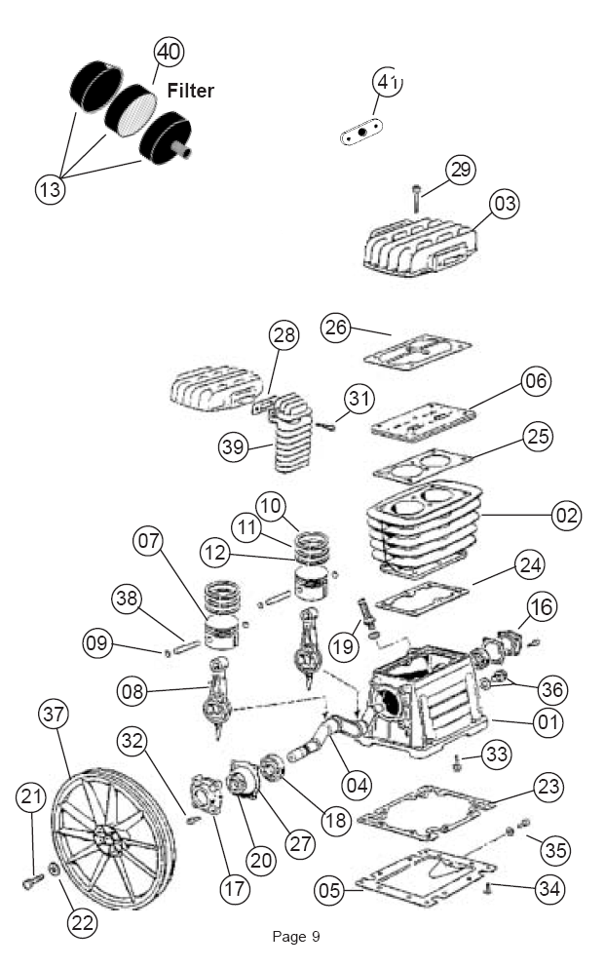
LOWE’S ITEM #: 134819
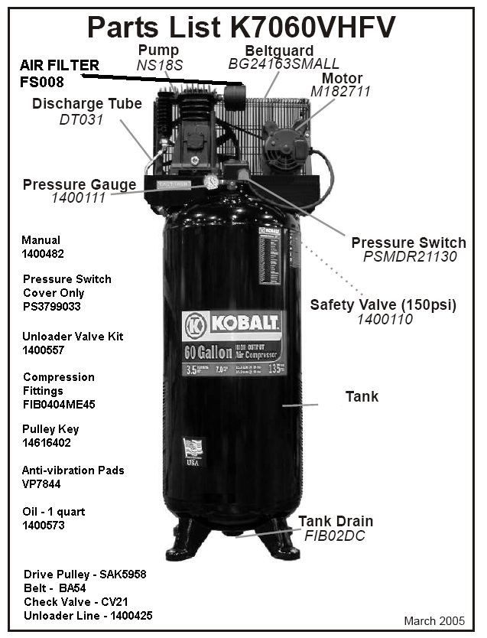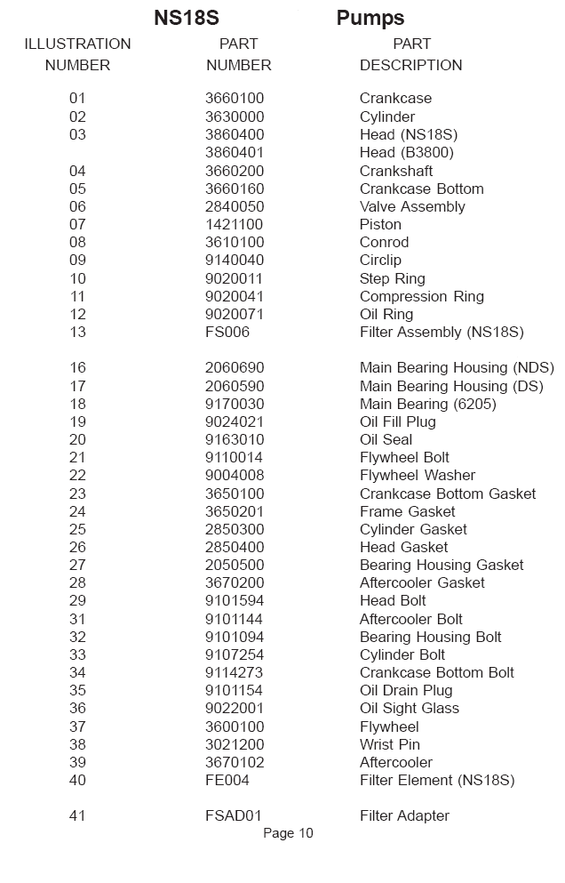
Notes:

RUN TIME/DUTY CYCLE: 30MIN 1HOUR / 50-100%; PUMP HAS TWO PISTONS SAME SIZE WORK TOGETHER
- 40WT NON-DETERGENT OIL MUST BE USED
- MUST HAVE 230VOLTS /1 PH
- 30 AMP BREAKERS
- CLEARANCE OF 18 INCHES BETWEEN WALL AND COMPRESSOR REQUIRED FOR PROPER VENTILATION
- LEAK/PROBLEM WITH VALVE BEHIND PRESSURE SWITCH COULD BE CHECK VALVE CUSTOMER CAN REMOVE AND CLEAN TRASH

- Torque specs on head are 18-20 ft lbs. After about 6 cycles, recheck the torque specs after replacing gaskets

