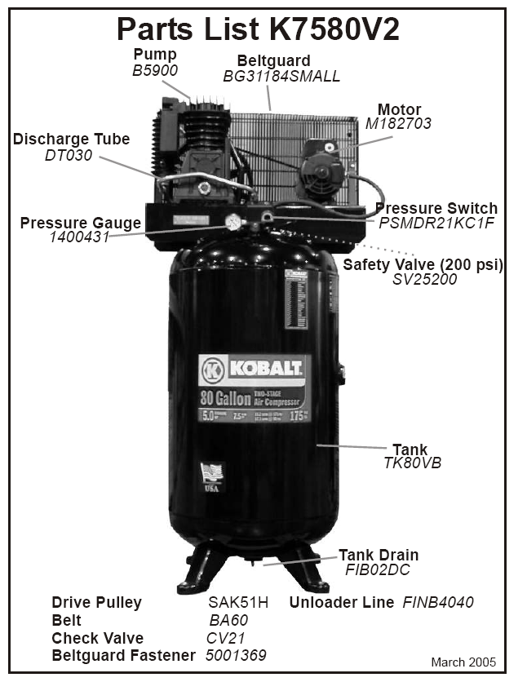
AIR FILTER - 5281000
LOWE’S ITEM #: 134749

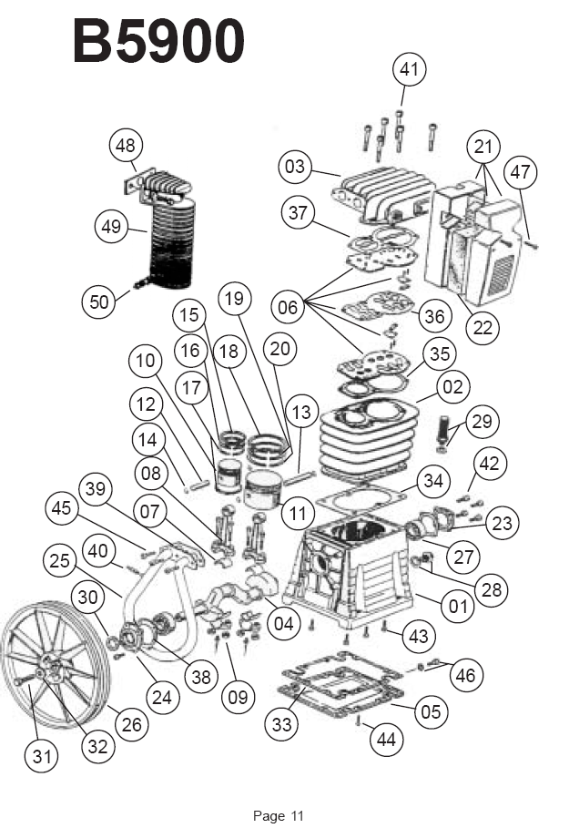

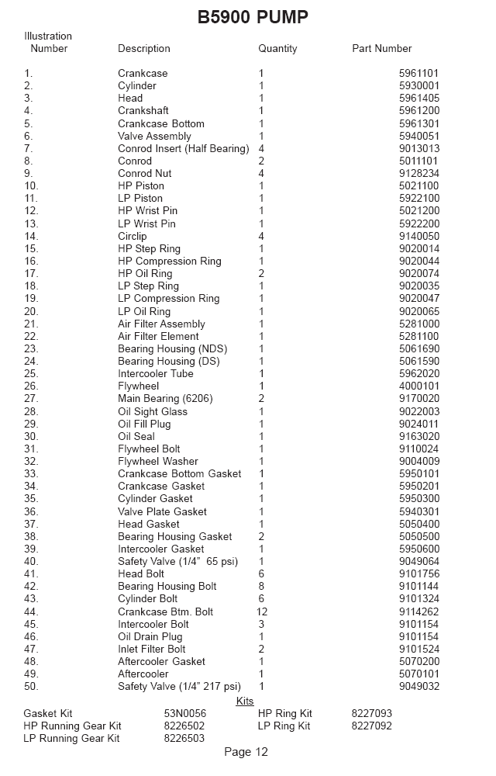
Notes:

RUN TIME/DUTY CYCLE: 45MIN 1HOUR / 50-100%; PUMP HAS TWO PISTONS DIFFERENT SIZE FOR TWO STAGE
- 30WT NON-DETERGENT OIL MUST BE USED
- MUST HAVE 230VOLTS /1 PH
- 40 AMP BREAKERS
- CLEARANCE OF 18 INCHES BETWEEN WALL AND COMPRESSOR REQUIRED FOR PROPER VENTILATION
- LEAK/PROBLEM WITH VALVE BEHIND PRESSURE SWITCH COULD BE CHECK VALVE CUSTOMER CAN REMOVE AND CLEAN TRASH

